Sample Zip
public/sample.zip
configured in public/js/app.js
var TEMPLATE_URL="/sample.zip"
prepare test data
env_sample.bat or .env_sample
node generateRealFrontendData
After deploy
open
http://localhost:3000/admin/help#exportSMG
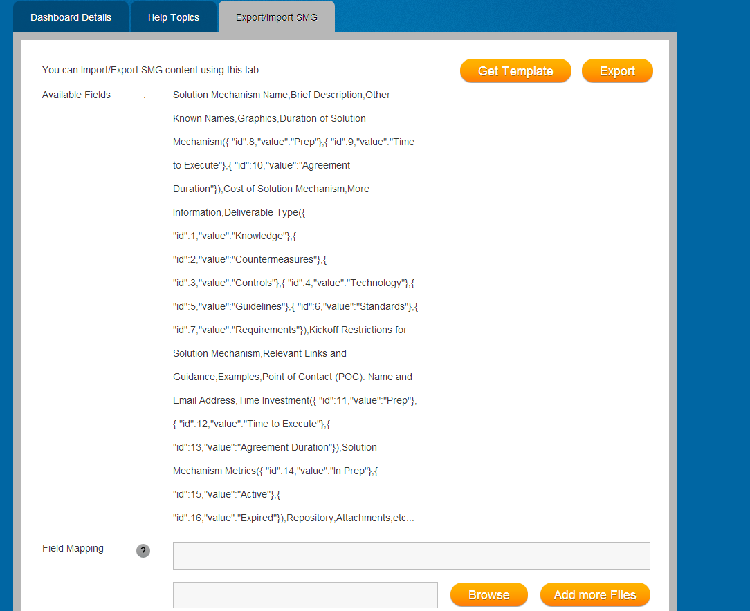

When click Get Template will download sample.zip
when click Export will download smgs.zip

it will use id of smg as file name
will use string value(if lookup/multi-value then values should be comma separated values)
exist field-mapping.csv to show the ordered
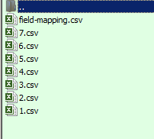
you can import such export files
If the import csv file are invalid then it will show details error message
for example rows in csv not match the Field Mapping
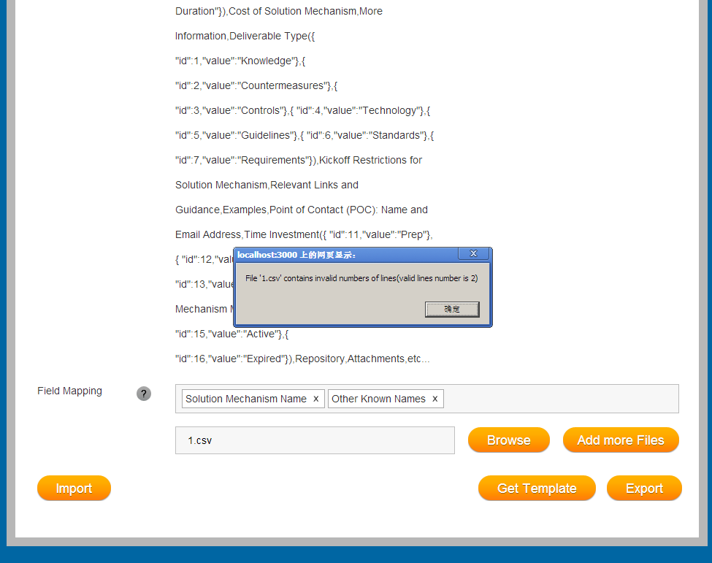
After import successfully
It will create SMG,SMGCharacteristic entity
It will set name/description null for SMG
One issue If you want to see the new created entity in admin page
http://localhost:3000/admin/smg
You must import SMG with Solution Mechanism Name,Brief Description,Other Known Names Fields
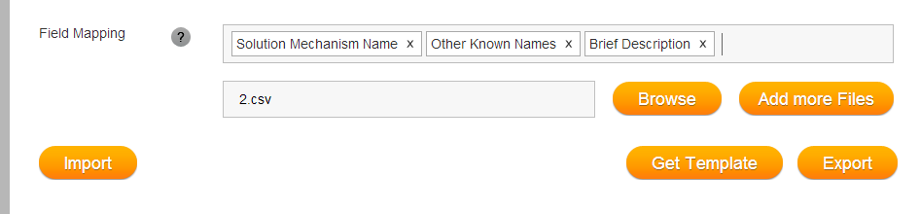
If you not import such fields
You will not see these new created smg entities in Admin pages
But if you use API URL or public page then you will see them
http://localhost:3000/api/smgs
http://localhost:3000/smg
Such new SMG will not be seen in admin page unless you add Solution Mechanism Name,Brief Description,Other Known Names Fields
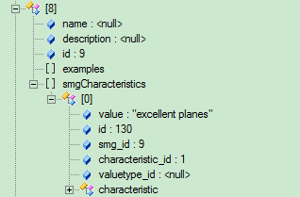
Because Admin SMG page will use such criteria and it will make sure below characteristic exist
var criteria = [
{characteristic: chIds.name, value: self.searchFilter.name().trim() || "%"},
{characteristic: chIds.aka, value: self.searchFilter.aka().trim() || "%"},
{characteristic: chIds.desc, value: self.searchFilter.desc().trim() || "%"}
];

